Instructions – remove this section
Basic instructions and tips (This style is Heading2)
- Important – Don’t delete any empty paragraph markers in header and footer, these markers are reserved for ‘Sensitivity labels’.
- Important – turn on the ‘Paragraph Markers’ , as this is especially useful for advanced layout tasks.
- Save the ‘Colour Palette’ on your computer – go to ‘Design’, then ‘Colors’ and click on ‘Customize Colors’, give it a ‘Name’ for example ‘INSW Independent Sept 2022 Navy+Fuschia’ and ‘Save’.
- Save the ‘Fonts’ on your computer – download the fonts first, then go to ‘Design’, then ‘Fonts’ and click on ‘Customize Fonts’, give it a ‘Name’ for example ‘NSWGOV Corporate Sept 2022’ and ‘Save’.
- Keep the ‘Document Title’ short – explain more in the ‘Document Intro’ or an introductory paragraph if you need to.
- Use ‘Styles’ to format paragraphs. Don’t manually format paragraphs. If the style doesn’t look right, put your cursor anywhere in the paragraph, click ’Clear All’ in ‘Styles’ pane, and reapply the correct style.
- Standard document text should use ‘Body Text’ style, not ‘Normal’ style.
- Whenever you paste text from another document, keep text only by right-clicking, under ‘Paste Options’ select ‘Keep Text Only’, then apply the relevant template styles. Don’t assume that styles have been correctly applied.
- Create bullet points using ‘List Bullet’, ‘List Bullet 2’ and ‘List Bullet 3’ styles. Don’t use the bullet button in the toolbar.
- Create numbered lists with ‘List Number’, ‘List Number 2’ and ‘List Number 3’ styles. Don’t use the list button in the toolbar.
- If your lists or bullets go more than 3 levels deep, they are too complex – simplify your content.
- Use ‘Page Break’, not ‘Section Break’ when necessary.
- Check ‘Accessibility’ – go to ‘File’ then ‘Info’ and in ‘Check for Issues’ click on ‘Check Accessibility’, then fix all the ‘Errors’.
- Once the document is finalised, make sure the TOC and the cross-references are updated. Select the entire document by clicking ‘Ctrl + A’, then right-click, select ‘Update Field’ and then select ‘Update Entire Table’. Then go through the document again and fix anything that looks odd, for example the page numbers.

Basic instructions for tables
Note: When inserting a new table, the default table style should be ‘List Table 3 – Accent 5’. If not, put your cursor anywhere in the table, go to ‘Table Design’ tab, in ‘Table Styles’ click the drop-down arrow, in ‘List Tables’ choose ‘List Table 3 – Accent 5’.
When inserting a table, text is automatically styled with ‘Body Text’ and the heading row will appear bold. Apply Bold, Italic or Bold Italic to text if additional styling is needed.
Add ‘Title’ and ‘Alt Text’ to a table by right-click anywhere in the table, select ‘Table Properties’ then go to ‘Alt Text’ tab and type in ‘Description’.
Table 1: Caption for tables, figures and images. To add a caption to a table, select the entire table then right-click and select ‘Insert Caption’. This table style is ‘List Table 3 – Accent 5’.
Box 1 (Body Text + Bold Fuschia 01)
Five‑year State Infrastructure Plan (Body Text + Bold Fuschia 02)
Body Text

Table 2: Caption for tables, figures and images. To add a caption to a table, select the entire table then right-click and select ‘Insert Caption’. This table style is ‘List Table 3 – Accent 6’.
Box 2 (Body Text + Bold Blue 01)
NSW Government actions to mitigate market pressures (Body Text + Bold Blue 02)
Body Text
Alternative table styles
Table 3: Caption for tables, figures and images. To add a caption to a table, select the entire table then right-click and select ‘Insert Caption’. This table style is ‘List Table 4 – Accent 5’.
Header is Body Text + Bold Fuschia 01

Table 4: Caption for tables, figures and images. To add a caption to a table, select the entire table then right-click and select ‘Insert Caption’. This table style is ‘List Table 4 – Accent 6’.
Header is Body Text + Bold Blue 01

Basic instructions for images and illustrations
Note: Add ‘Alt Text’ by right-click anywhere in the image then select ‘Edit Alt Text’, and type in description of the image or tick ‘Mark as decorative’ if the image is for decoration purpose only.
How to change an image in the Header – ‘Acknowledgement of Country’ for example: Double-click in the Header, right-click on the image, select ‘Change Picture’ and then find a new image, click ‘Close Header and Footer’.
How to change an image in text – the Cover image for example: Right-click on the image, select ‘Change Picture’ and then find the new image.
How to change the shape colours – the coloured shape on the Cover for example: Right-click on the shape, select ‘Format Shape’, in ‘Fill’, change to new colours.
Image 1: Caption for tables, figures and images. To add a caption to an image, select the image then right-click and select ‘Insert Caption’.


Basic instructions for charts
Note: Figure 1 below is an editable working chart, your final document should not have any of these editable charts, keep a separate file for editing.
Figure 1: Caption for tables, figures and images. To add a caption to a chart, select the chart then right-click and select ‘Insert Caption’.

Note: Figure 2 below is a non-editable image generated from Figure 1 for accessible document.
Process: Once Figure 2 is finalised, single-click on the editable chart then Ctrl + C. Put your cursor at the beginning of an empty paragraph then right-click, in ‘Paste Options’ select the 3rd one – ‘Picture’, then right-click anywhere in the image select ‘Edit Alt Text’.
Figure 2: Caption for tables, figures and images. To add a caption to a chart, select the chart then right-click and select ‘Insert Caption’.
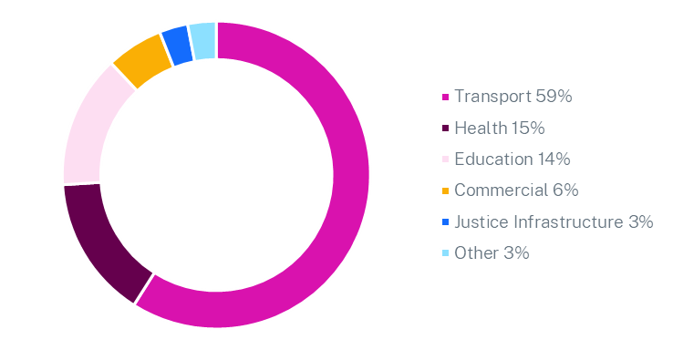

Figure 3: Caption for tables, figures and images. To add a caption to a chart, select the chart then right-click and select ‘Insert Caption’.

Heading1 Numbered

Heading2 Numbered

Heading3 Numbered

Heading4 Numbered

Heading5 Numbered

Heading2

Heading3

Heading4

Heading5

Heading1
Heading2
Heading2+Blue 02
Note: Headings 2 to 5 default colour is Fuschia 01. If you want to use Blue Headings instead, select the Heading and apply ‘Blue 02’ character style.
Heading3
Heading3+Blue 02
Heading4
Heading4+Blue 02
Heading5
Heading5+Blue 02

- List Bullet
- List Bullet
- List Bullet 2
- List Bullet 2
- List Bullet 3
- List Bullet 3

- List Number
- List Number
- List Number 2
- List Number 2
- List Number 3
- List Number 3

Pull out quote. Body Lorem ipsum dolor sit amet, consectetuer adipiscing elit. Maecenas porttitor congue massa. Fusce posuere, magna sed pulvinar.

Infrastructure NSW

Business Case Summary
  - Title
[Click here to enter a Date]
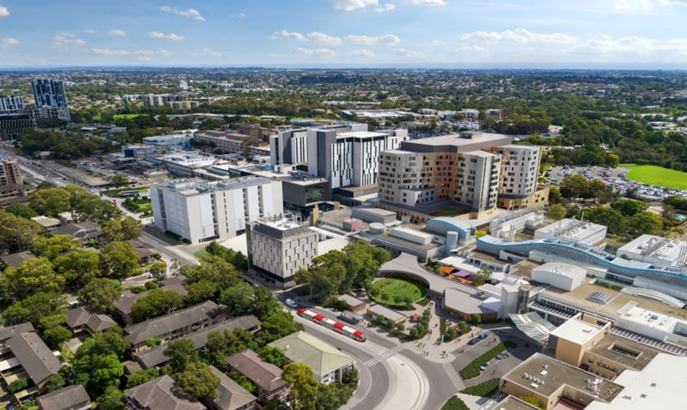
Image: NorthConnex, March 2022, or NSW

Contents
1 Instructions – remove this section i
Basic instructions and tips (This style is Heading2) i
Basic instructions for tables ii
Basic instructions for images and illustrations iii
Basic instructions for charts iii
2 Heading1 Numbered v
Heading2 vi
Heading2+Blue 02 vi
3 About this report 9
[Project Name] 9
Major Infrastructure Project pathway 9
4 Strategic alignment and context 10
5 Project Need 11
6 Project objectives and design 12
7 Options identification and assessment 13
8 Cost and Economic evaluation 14
9 Deliverability 15
10 The Infrastructure NSW view 16

About this report
[Guidance Note: Keep this section to maximum of 1 page.]
[Project Name]
[Guidance Note: Note this Summary is to be published on Infrastructure NSW’s website.
Any disclosure of costs, scope, design features or project timeframes should be high-level given the project is yet to commence procurement and design to be further developed. This Summary must align with the Premier’s Memorandum Information on Infrastructure Projects].

The [project/program name] is designed to ….[explain key benefits and how it addresses the service need].

The Business Case for the [project/program name] was developed by …. and submitted to Government for an investment decision on [day] [month] 202X.
This summary was submitted with the Business Case to [Government/the Minister], to support an investment decision. The summary will be published on Infrastructure NSW’s website.
Major Infrastructure Project pathway
[Guidance Note: Explain who will consider this Business Case and what the key next steps are.]
[Guidance Note: Include the flow chart below. The purpose is to help the public understand the next stages of the project’s development and delivery.]
Figure [X] Infrastructure project procurement and delivery pathway
Current stage

Strategic alignment and context
[Guidance Note: Keep this section to maximum of 2 pages.]

Alignment with Government Strategies & Policies
[Guidance Note: Outline strategic importance of the project for NSW.]

[Government priorities / strategies]:
  xx  - x |   x  - x |   x  - x

Body text

Title (Figure 4).
Figure 4: xx

Project Need
[Guidance Note: Keep this section to maximum of half a page.]

[Guidance Note: Outline the key drivers of the project including, government responsibilities, stakeholder requirements and general community benefits/needs]

[Demand/Service Forecast Fact/figures]:
x | x | x
- x | - x | - x

Project objectives and design
[Guidance Note: Keep this section to maximum of 1 page.]

Objectives
The primary objectives of the [insert project/program name] are:
- List bullet
- List bullet
- List bullet
- List bullet
- List bullet

Design
[Specifics regarding the design of the project]
[Note any particular heritage, community or environmental considerations and how they will be managed, e.g. the planning exhibition and community engagement processes]

Options identification and assessment
[Guidance Note Keep this section to maximum of 2 pages.]

Strategic Business Case
The Options that were considered as part of the Strategic Business Case include:
- List bullet
- List bullet
- List bullet

Final Business Case
The preferred option is [preferred option] because…
[Guidance Note: Include the assessment and outcome of alternative solutions (inc. non-infrastructure solutions)]
Body text

Commercial and Financial Structure
[Guidance Note: Provide detail on:
- Delivery Model: PPP, Lump Sum D&C, Alliance, Managing Contractor, TOC, ECI.
- Funding Structure: PPP, Government-funded, hybrid
- Commercial Operating Model: outsourced/insourced O&M, licensed operations, key revenue and cost streams]

Stakeholder Engagement
[Guidance Note: Outline any community/key stakeholder consultation processes already completed and note where there may be future consultation to come.]

Cost and Economic evaluation
[Guidance Note: Keep this section to maximum of 1 page (including tables).]

Estimated Costs
[Guidance Note: it is not recommended to provide a single estimated total cost figure for the project, instead provide a cost range in line with Infrastructure NSW’s Information on Infrastructure Projects - A Guide. ]
[The NSW Government has committed $X to the project]
[The estimated total cost of the project is between $X million and $Y million. Certainty on costs will increase following procurement of the project.]
[The estimated operations cost (Opex) is $X million per year]

Evaluation
[Guidance Note: Outline who undertook the economic evaluation, any consultation with NSW Treasury and what was included/excluded]
[The purpose of the economic evaluation is to estimate the economic, social, and environmental costs and benefits of the Project in monetary terms. [Agency] completed the economic appraisal and financial appraisal in consultation with relevant stakeholders:
- Economic appraisal: to evaluate the Project options by undertaking an economic cost benefit analysis (CBA) consistent with the relevant guidelines.
- Financial appraisal: to evaluate the financial viability of the Base Case and the Project options, including the estimated impact to the whole-of-Government budget.
Body text

Outcomes of the Analysis
[Guidance Note: Present the results of the economic evaluation including a table with the summary present value cost benefit analysis results and benefit-cost ratio. The agency may choose to present only the preferred option.]
Table X: Summary of the Project’s CBA
Option appraisal | Criteria | Option 1 | Option 2 | Option 3
Economic appraisal ([7.00%] real discount rate) | Average NPV ($ million) | -$X,XXX | -$X,XXX | -$X,XXX
Economic appraisal ([7.00%] real discount rate) | Average BCR | Y.Y | Y.Y | Y.Y
Economic appraisal ([3.00%] real discount rate) | Average NPV ($ million) | -$X,XXX | -$X,XXX | -$X,XXX
Economic appraisal ([3.00%] real discount rate) | Average BCR | Y.Y | Y.Y | Y.Y

Deliverability
[Guidance Note: Keep this section to maximum of 1 page.]

Procurement
[Guidance Note: Outline how the project is to be procured and delivered]

Timeframe
[Guidance Note: Outline when the project is anticipated to be constructed and open for operation.
Note, for complex projects, it is not recommended to provide exact dates, instead provide a range of years in line with Infrastructure NSW’s Information on Infrastructure Projects - A Guide]

Key risks and mitigation
[Guidance Note: Outline the key risks associated with the development and delivery of the project that are identified within the business case]
Table X: Key Project Risks
Key Risk | Details
[Project approvals] | Body text
[Environmental impacts] | Body text
[Community and Landowners] | Body text

The Infrastructure NSW view
[Guidance Note: Keep this section to maximum of 1 page.]
[Infrastructure NSW to complete this section which provides a summary of their view on the project and high-level findings from the gateway review process]

Weblink: https://www.infrastructure.nsw.gov.au/media/3611/information-on-infrastructure-projects-guide-may-2022.pdf
Weblink: https://www.infrastructure.nsw.gov.au/media/3611/information-on-infrastructure-projects-guide-may-2022.pdf

